**Version Controlling is user for**

* **team collaboration**
* **versioning**
* **backup**

**Distributed version controlling> ever developer has same copy**

**Git is version control system**

**Git works with>>GitHub**

**>>BitHub**

**>>Gitlab**

**All this three use Git command language**

**Steps to create Git repository**

1. **Create local folder**
2. **Open the folder using Git command or CMD terminal on mac**
3. **Git init**
4. **Git config user.name “itjrdg” for local folder or git config –global user.name “itjrdg**
5. **Git config –unset user .email for local folder or –global for remote folder(to delete or correct mistake)**

**Local Machine. >> CraftUserManagement**

**Staging Area. >> Git Add . for all or Git add file name for each**

**Git status**

**Git commit -m “message description”**

**Git log shows commit details**

**Git log –oneline displays message in one line**

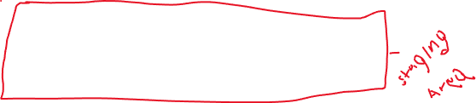

* **Last file comiit is called HEAD**

**Git branch -M main ( main is a convention name in GitHub). This is set by default**

**Remote**

**Git remote add origin url (here sometimes, token code is required and it must be placed after the https:// followed by @the url)**

**Git remote -v ( to view what we have added)**

**Git push -u origin main ( required when pushing to github first time)**



**create a new repository on the command line**

**echo "# CraftUserManagement" >> README.md**

**git init**

**git add README.md**

**git commit -m "first commit"**

**git branch -M main**

**git remote add origin https://github.com/itjrdg/CraftUserManagement.git**

**git push -u origin main**

**git restore file name**

**git revert ( to go back to specific file) or HEAD~1**